Project 6 Report

1. Himalayan Adventurers

2. Amna Tanveer, Jacob Lemley, Nachiket Vamshidhar, Kaitlin Forsythe

3. Description:

You wake up suddenly, on an icy ground with a cold breeze gushing at you from every direction. The air is dry. You look up and there are mountain ranges surrounding you from lengths of 2,400 km. The feeling of confusion is creeping up on you; you think, "How did I get here?" A wooden board on your far left says, "Welcome to the Himalayas," but there is no one to be found. The view is beautiful yet ominous, since ice caps are melting around you, and the famous Himalayan black-necked cranes skulls are surrounding you in masses. You walk around or across the still river in hope to find someone, but you find yourself in loss of words as you see a village flooded from afar. As a UT environment student, you believe it is your responsibility to report this to the world by taking up any remaining artifacts; the problem is that one of the artifacts will take you back home without any recollection of your stay at the Himalaya's, so be careful in what you chose to pick up. Also, the goal is to collect as many artifacts/details as you can. Maybe one of them can help you get home.

4. Simple User Manual:

When the program starts, the introduction is printed. Type in commands like GO <direction>, PICK UP <object>, DROP <object>, LOOK at <object>, or HELP to get a list of commands and tips. To exit, type EXIT. Your goal is to find a way out of the Himalayas using tools found throughout the map and collect valuable artifacts to pay off your student debt. Other commands not listed above might be available in certain areas.

5. Topics from the Solution Requirements List and their Location:

* Function Definition and Function Call (7) - line
* Function Definition with Parameters and Function Call (10) - line
* Function Definition with Default Parameters and Function Call (12) - line
* Recursive Function Definition and Recursive Function Call (17) - line
* A function that calls another function (main not included) (5) - line
* Assignment Statement (3) - line
* 2 Styles of Comments (single and multiline) (3) - line
* File Reading (15) - line
* File Writing (15) - line
* If Statement (5) - line
* Nested If Statement (7) - line
* For loop (7) - line
* While loop (7) - line
* A Class (20) - line
* List (10) - line
* Tuple (15) - line
* Set (15) - line
* Dictionary (15) - line
* A list that contains lists (20) - line
* Convert between Data Structures (List, Tuple, Set, etc.) for a purpose (13) - line
* Convert between string and list (or list and string) for a purpose (7) - line
* Nested Loops (12) -line
* Python code that “walks” through the contents of an List (or other data structure) (7) - line
* Finding the largest or smallest item in an List (not built-in) (10) - line
* Using build-in List (or other data structure) functionality (so a function like insert or append) (3) - line
* Sorting of the contents of an List (not the built-in sort) (20) - line
* Try/Except Block (15) - line
* Using +=, -=, etc (3) - line
* Using len with a purpose (and not within a different piece of code you are getting points for) (2) - line
* print() statement (2) - line
* Using the formatting for strings (with print() statement) (5) - line
* Random Number Generator (10) - line
* Import another Python file and use functionality (10) - line
* Flowchart or Design of the Entire Program (required) (20) - line

6. A flowchart or design of the entire program:

Type MAP in game to view a flowchart and other project details.

This is what the map looks like when the program returns it.

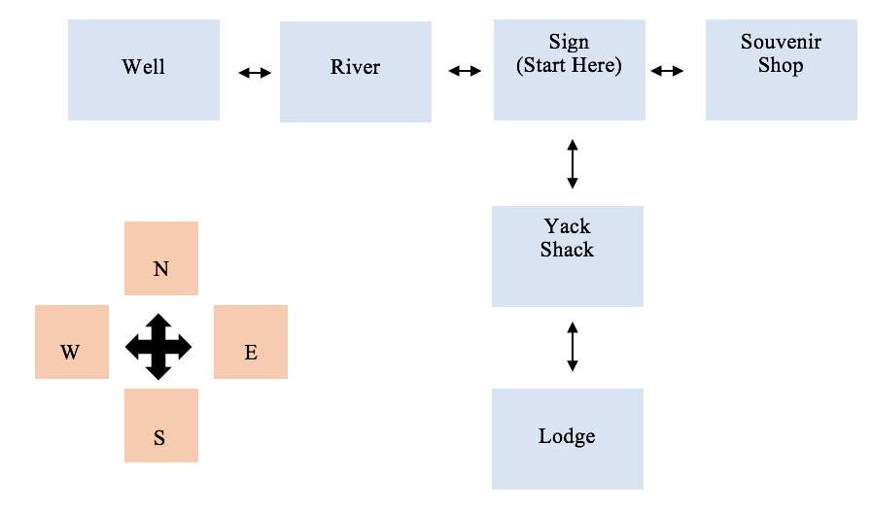

7. Any known errors or problems with your program

8. Any messages to the instructor:

We hope you enjoy our game!